**Software Engineering Department**

**Course Name: CMPE235– Mobile Software Design.**

Student Name: Vibhava Rayala

Instructor: Chandrasekhar Vuppalapati, Professor

Assignment #1: Demonstrating Activity life cycle by creating two activities and a dialog box and a counter that increments and resets based on the activities performed.

**Summary:**

This document contains step by step demonstration of Activity Lifecycle which involves creating two different types of activities, **Activity A and Activity B** and **a counter** and **a dialog box**. The counter begins incrementing as soon as the application is opened, and the counter resets when activity B is returned to activity A. The counter increments even in the background, when a dialog box is opened and different operations on dialog box are performed when it’s in Activity A.

**Objectives:**

1. Create 2 Activities. Activity A and Activity B
2. Create a counter which increments as soon as the application is opened.
3. The counter should be reset when the control is shifted from Activity A to Activity B.
4. Create a dialog box in one of the activity. I created the dialog box in Activity A.
5. The counter should be incrementing in the background even when the dialog box is opened in Activity A.

**Requirements:**

1. Must have Android Studio, or IntelliJIDEA platform, which supports development of android applications.

**How to do it? :**

1. I created two activities Activity A and Activity B and a counter and a dialog box. The Button that opens the dialog box and Activity B is kept in Activity A page. As soon as you open my androidassignment application , this is the screen you will get with the counter automatically incrementing as soon as you open it

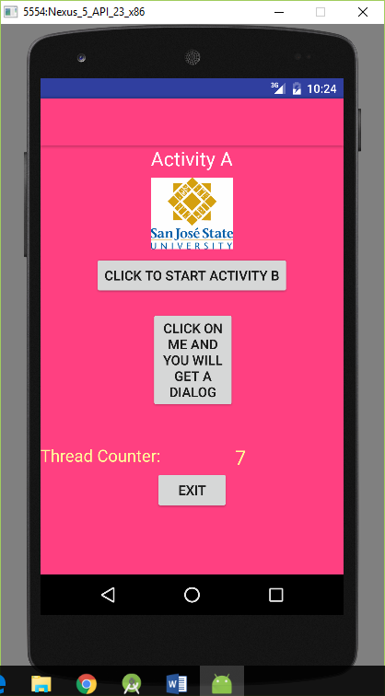

1. Now when you click **CLICK TO START ACTIVITY B** button on the home screen, you will redirected to the following page, Activity B sets the counter to zero, as the control is shifted from Activity A to Activity B, When you click Exit activity B button, the counter resets to zero.

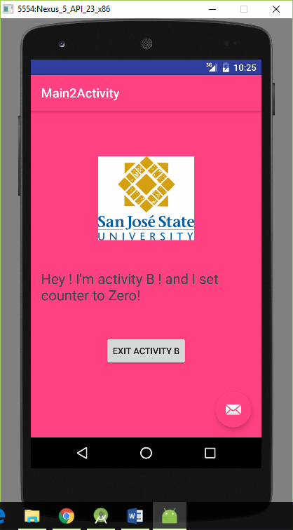

1. When you click the **Exit Activity B** button above, you can see that the page is redirected to activity A and the counter is reset.

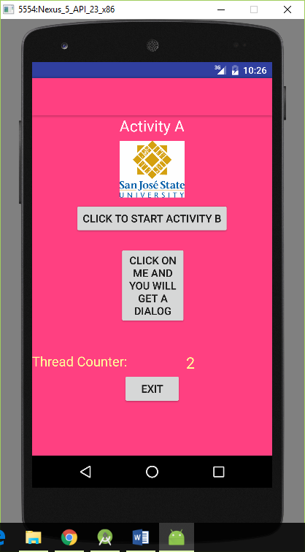

1. When you click the **Click on me and you will get a dialog button** above it will prompt you with a dialog box with yes or no operations like so. When you click Yes, the counter still increments in the background as the activity control is **not** shifted from A.

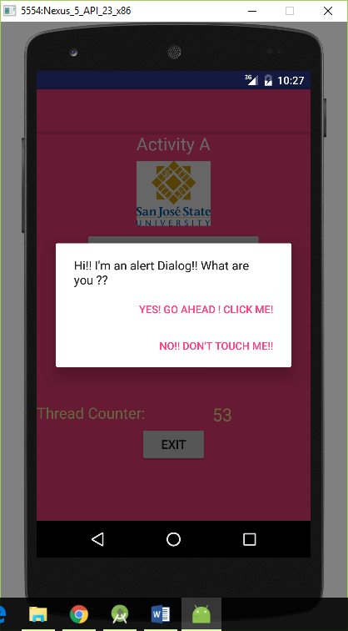

1. As you can see the Thread Counter got incremented in the background even when the dialog box is opened, in activity A.

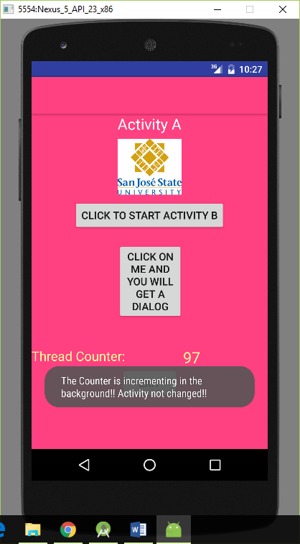

1. The counter increments in the background, even when you press NO, as the activity is still with A and is not shifted to B.

